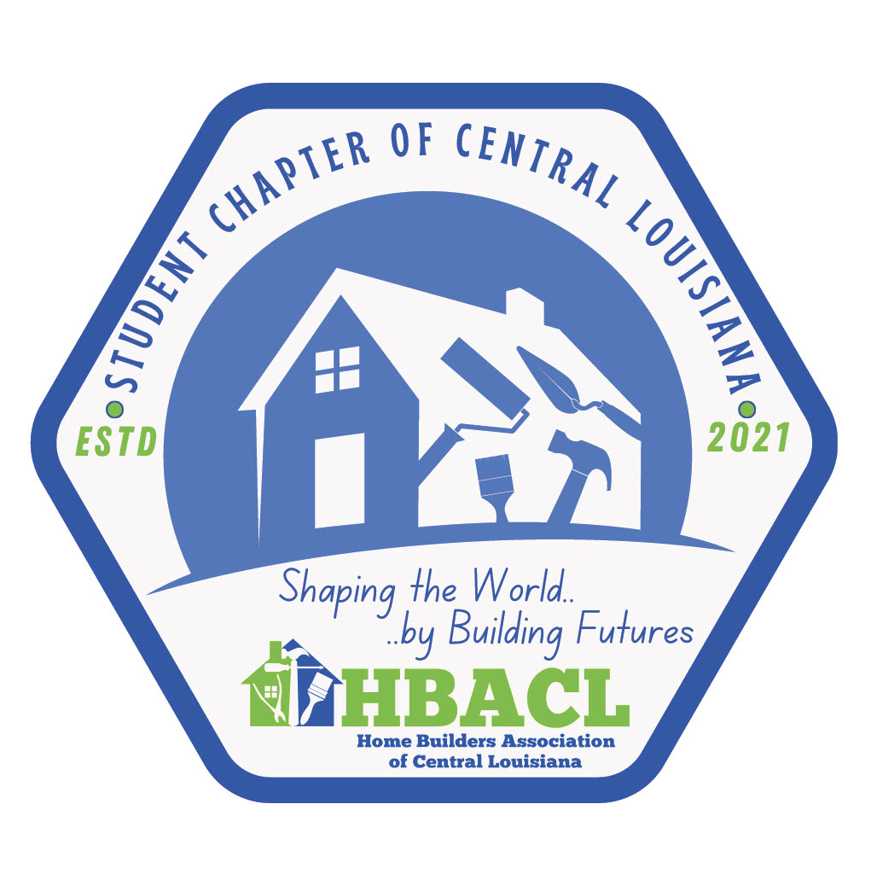

Support the Future of Homebuilding – Become a Sponsor Today
At the Student Chapter of Central Louisiana – HBACL, we are shaping the next generation of skilled professionals, community leaders, and change-makers. Through hands-on learning, mentorship, and real-world experience, students from Tioga and Grant High Schools are building more than homes — they’re building futures.
Your sponsorship is more than a donation. It’s an investment in youth, in workforce development, and in the prosperity of Central Louisiana. With your support, we can provide scholarships, host career-readiness events, and expand our reach to more schools and students.
Join us in our mission to build brighter, stronger communities — one student at a time.

Sponsorship Tiers
- **Platinum – $5,000+**
Premier recognition on all platforms/media and at all events all year, scholarship presenter, VIP access to events, and much more!
- **Gold – $2,500**
Logo on select materials, social media features, event invitations, and much more!
- **Silver – $1,000**
Name/logo on select materials, student event invites.
- **Supporter – Under $500**
Website/Facebook thank you, and event invites.
- **Scholarship Sponsor – $1,000+ (2-year commitment)**
Direct support to student, recognized in awards ceremony & materials.

Sponsorship Commitment
Organization Name: _______________________________________
Contact Person: __________________________________________
Phone Number: ___________________________________________
Email Address: ____________________________________________
Mailing Address: __________________________________________
City: ______________ State: _____ Zip: _____________
- Please select your sponsorship level:
☐ Platinum – $5,000+
☐ Gold – $2,500
☐ Silver – $1,000
☐ Supporter – Donation Amount: $______________
☐ Scholarship Sponsor – $1,000+ (2-year commitment)
- Payment Method:
☐ Check (payable to HBACL)
☐ Online Payment (please call 318-443-1902 for assistance)
Authorized Signature: _______________________________________
Date: ____________________

Please return this completed form via email or mail to:
Student Chapter of Central Louisiana
2017 MacArthur Drive
Alexandria, LA 71301
Michael Bolen – Chapter Chairman
📞 318-451-3088
✉️ michael@nextgenerationinsulation.com
Becki Hesni – Office Administrator
📞 318-443-1902
✉️ info@hbaofcenla.org

