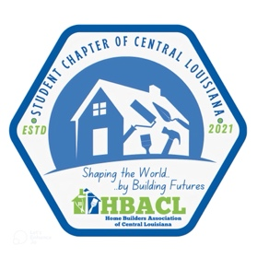 Student Chapter
Calendar of Events

August - 8 Grant High 1. Meet and Greet
2. Sign up new students/ Appoint 1 seat on BOD
3. Introduce Scholarships
15 Tioga High 1. Meet and Greet
2. Sign up new students/ Appoint 1 seat on BOD
3. Introduce Scholarships

September 20 Chapters Fundraiser projects at Home Show

October 17 HBACL Skeet Shoot

November 20-21 Chapters Seco Expo

December 19 Grant High Bonfire
20 Tioga High Bonfire

January 17 Grant High Movie Night
24 Tioga High Movie Night
February 17 Chapters Alexandria Children’s Mardi Gras Parade
March 1 Chapters Scholarship Projects Due at HBACL office
1 Chapters Written portion of Scholarship due at HBACL office

April 11 HBACL Golf Tournament
15 Chapters Notification of Scholarship Awards
TBD Chapters FFA Field Day

May 1 Chapters End of Year Wrap up and crawfish boil

June Chapters Summer Internship/Job Placement

July TBD Chapters Student Chapter Leadership Canoe Trip

